FitTrack AI

AI-Powered Fitness Tracker Backend REST API
Project: FitTrack AI – Personalized Fitness Recommendations Powered by AI
Technology: Node.js, Express.js, MongoDB Atlas, Mongoose, JWT, bcrypt.js, Google Gemini AI
Project Type: Secure AI-Augmented Fitness Tracking Backend

Abstract
FitTrack AI is a secure backend REST application for recording, searching, and analyzing personal workouts. It uses Node.js, Express.js, MongoDB Atlas, Mongoose, JWT authentication, bcrypt password hashing, and Google Gemini AI. Authenticated users can manage their own workout history, search workouts, request personalized workout recommendations, and receive fitness insights. The expanded backend also supports text document uploads, embeddings, semantic and vector search, RAG chat, summarization, content generation, activity logs, and admin APIs.

Introduction
Fitness users often record workouts in notebooks, spreadsheets, or disconnected applications. This creates inaccurate history, slow calculations, and difficulty finding previous activities. Traditional trackers also do not provide guidance based on a user’s age, goal, experience, or workout statistics. FitTrack AI combines reliable backend storage and authentication with Gemini-powered recommendations and insights to make workout tracking more useful and personalized.

Project Title
FitTrack AI – Personalized Fitness Recommendations Powered by AI

Project Description
FitTrack AI is a secure REST API platform for workout management and AI-assisted fitness guidance. Users register, log in, and receive a JWT token. They can add, view, update, delete, and search personal workouts. AI endpoints generate workout recommendations from age, goal, and experience, and fitness insights from workout statistics. The system also supports document-based RAG chat and administrator management APIs.

Problem Statement

5.1 Manual Content Creation
Recording workouts manually is time-consuming and causes missing or incorrect entries.

5.2 Manual Summarization
Users must manually calculate duration, calories, and progress from raw workout records.

5.3 Content Organization
Workout history becomes difficult to organize and search as the number of activities increases.

5.4 Permission Management
Personal fitness records must be accessible only to their authenticated owner.

5.5 Traditional Search Limitations
Keyword search does not answer questions or retrieve conceptually related fitness information.

5.6 Security Issues
Passwords, protected routes, validation, and user data isolation must be handled securely.

Proposed Solution
FitTrack AI provides secure authentication, user-scoped workout CRUD, keyword and semantic search, Gemini workout recommendations, fitness insights, document upload, embeddings, RAG chat, summarization, content generation, activity logs, and admin APIs.

Objectives

7.1 Primary Objectives
1. Develop a secure fitness tracking REST API.
2. Implement JWT authentication and password hashing.
3. Implement user-level workout data isolation.
4. Provide complete workout CRUD operations.
5. Integrate Google Gemini AI.
6. Generate personalized workout recommendations.
7. Generate fitness insights from workout statistics.
8. Implement semantic and vector search with local fallbacks.

7.2 Secondary Objectives
1. Reduce manual workout tracking effort.
2. Improve workout discovery.
3. Provide role-based administration.
4. Support document-based AI question answering.
5. Provide testable and modular backend services.

System Requirements

8.1 Software Requirements
Component | Requirement
Operating System | Windows 10/11, macOS, or Linux
Runtime | Node.js
Backend Framework | Express.js
Database | MongoDB Atlas
ODM | Mongoose
Authentication | JWT
Password Security | bcrypt.js
AI Service | Google Gemini
Search | Atlas Search and Vector Search with fallbacks
API Testing | Postman, Thunder Client, and end-to-end tests

8.2 Hardware Requirements
- Intel Core i5 8th Gen or equivalent
- 8 GB RAM minimum; 16 GB recommended
- 1 GB project storage
- Internet connection for Atlas and Gemini

Technology Used
Node.js, Express.js, MongoDB Atlas, Mongoose, JWT, bcrypt.js, Google Gemini through `@google/genai`, Multer, dotenv, Morgan, Postman, and local cosine-similarity fallback.

System Architecture
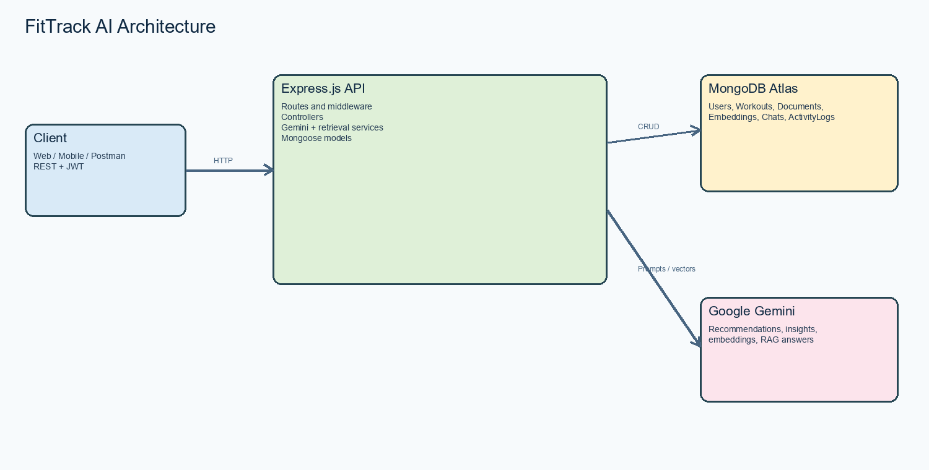
Figure 1: FitTrack AI system architecture.
Client -> Express Routes -> JWT/Role Middleware -> Controllers
-> Gemini Service
-> Retrieval Service
-> Mongoose Models -> MongoDB Atlas

The architecture diagram shows the API client, Express application, MongoDB Atlas collections, and Google Gemini services.

MVC Architecture

11.1 Model Layer
User, Workout, Document, Embedding, Chat, and ActivityLog Mongoose models.

11.2 Controller Layer
Authentication, workout, AI, document, and admin controllers.

11.3 Routing Layer
Express routes for `/api/auth`, `/api/workouts`, `/api/ai`, `/api/documents`, and `/api/admin`.

11.4 Service Layer
Gemini service, retrieval service, and activity service.

Database Design
MongoDB Atlas stores Users, Workouts, Documents, Embeddings, Chats, and ActivityLogs.

User Entity
Fields: `_id`, name, email, hashed password, role, createdAt, updatedAt.

Workout Entity
Fields: `_id`, user reference, workoutName, category, duration, caloriesBurned, workoutDate, timestamps.

Document Entity
Fields: `_id`, title, content, originalName, mimeType, size, uploadedBy, embeddingStatus, timestamps.

Embedding Entity
Fields: `_id`, document reference, user reference, chunkIndex, text, vector, model, timestamps.

Chat Entity
Fields: `_id`, user reference, message, response, mode, sources, timestamps.

ActivityLog Entity
Fields: `_id`, user reference, action, resourceType, resourceId, metadata, timestamps.

Entity Relationship Diagram
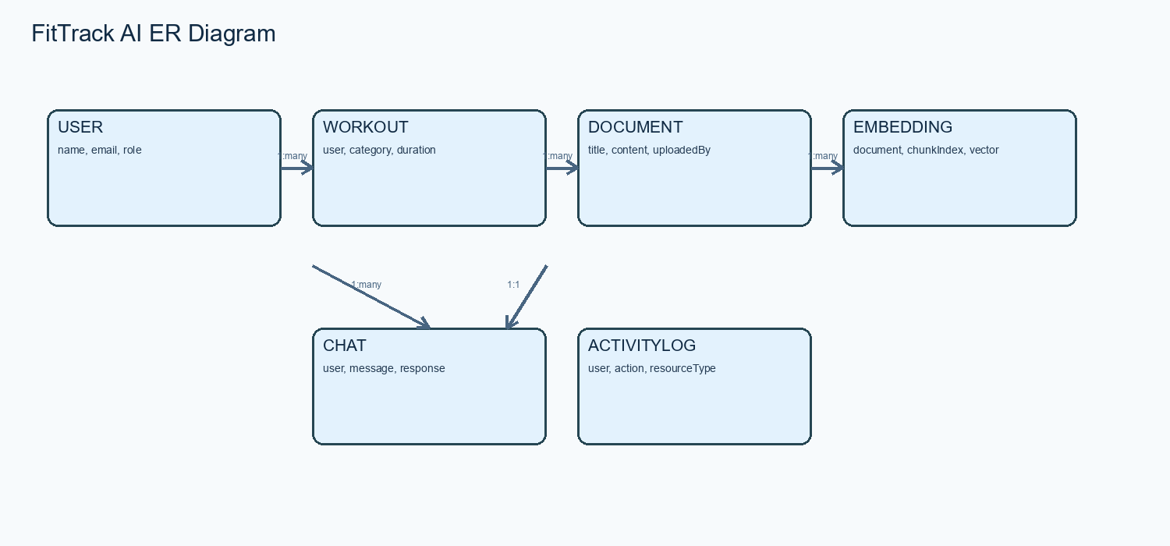
Figure 2: FitTrack AI entity relationships.
A User owns Workouts, uploads Documents, creates Chats, and generates ActivityLogs. A Document produces multiple Embeddings. Every workout and document query is scoped to the authenticated user.

User Roles and Responsibilities

19.1 Admin
Manage users, roles, documents, activity logs, and system summary.

19.2 Authenticated User
Register, log in, manage personal workouts, upload documents, search content, use RAG chat, and request AI recommendations.

Role-Based Access Control
Operation | Admin | User
Manage own workouts | Yes | Yes
Manage any workout | Yes | No
Upload documents | Yes | Yes
Request AI features | Yes | Yes
Manage user roles | Yes | No
View activity summary | Yes | No

Authentication and JWT
`POST /api/auth/register`, `POST /api/auth/login`, `POST /api/auth/logout`, and `GET /api/auth/profile` are implemented. Protected requests use `Authorization: Bearer <JWT_TOKEN>`.

Workout Management
Workout APIs provide create, list, retrieve, update, delete, and search. Search supports name, category, and date. Ownership protection prevents access to another user’s workouts.

AI and Document Features
Gemini generates workout recommendations, fitness insights, summaries, and content. Users can upload text documents, create embeddings, search semantically, and ask RAG questions with retrieved context.

MongoDB Atlas Search and Vector Search Index
Atlas Search uses `document_search_index` on `documents.title` and `documents.content`. Vector Search uses `document_vector_index` on `embeddings.vector` with cosine similarity. Local fallbacks keep the API usable when indexes are unavailable.

Semantic Search
`POST /api/ai/semantic-search` retrieves conceptually related document chunks using Gemini query embeddings and vector retrieval. The system falls back to local cosine similarity when necessary.

MongoDB Atlas Search
`GET /api/documents/search?q=<term>` performs keyword or Atlas Search across uploaded documents, with a keyword fallback.

Security Features
- bcrypt password hashing
- JWT authentication
- Protected routes
- User-level data isolation
- Input validation
- Safe error responses
- Environment-based secrets
- Role-based admin middleware

API Module Summary
Module | Endpoints
Auth | `/api/auth/register`, `/login`, `/logout`, `/profile`
Workouts | `/api/workouts` CRUD and search
AI | `/api/ai/workout-recommendation`, `/fitness-insights`, `/chat`, `/semantic-search`, `/summarize`, `/content-generator`
Documents | `/api/documents` upload, list, search, analyze, delete
Admin | `/api/admin/users`, `/documents`, `/activity`, `/summary`

API Testing
Testing uses Postman, Thunder Client, and repeatable end-to-end tests.

Testing Results
Test suite | Passed | Failed
Core API end-to-end suite | 19 | 0
Expanded AI feature suite | 19 | 0
Focused RAG suite | 4 | 0

System Functionality Summary
Authentication, authorization, workout management, document management, embeddings, semantic search, Atlas Search, Vector Search, RAG chat, AI recommendations, AI insights, activity logs, and admin APIs.

Advantages
- Centralized workout history
- Secure user data
- Personalized AI guidance
- Semantic and keyword search
- Modular MVC structure
- Reusable AI and retrieval services

Limitations
- Backend-only project
- Atlas index configuration is required for native search
- Gemini availability affects AI endpoints
- PDF and Office document parsing is not included
- Admin dashboard is API-based rather than a frontend screen

Future Enhancements
- Web and mobile frontend
- Progress dashboard and charts
- Nutrition and BMI tracking
- Wearable integration
- Workout reminders
- PDF parsing
- Richer AI fitness coaching

Conclusion
FitTrack AI demonstrates how traditional backend development can be augmented with AI. Secure authentication, user-scoped workout management, Gemini recommendations, fitness insights, document embeddings, Atlas Search, Vector Search, RAG chat, and admin services provide a practical and extensible fitness platform.

Selected Project Code
// src/server.js
require('dotenv').config();
const app = require('./app');
const connectDB = require('./config/db');
connectDB();
const server = app.listen(process.env.PORT || 5000);

// JWT-protected AI route
router.use(protect);
router.post('/workout-recommendation', getWorkoutRecommendation);

// Gemini request
const response = await ai.models.generateContent({
model: process.env.GEMINI_MODEL,
contents: prompt
});

// User-scoped workout query
const workouts = await Workout.find({ user: req.user._id });

